Department of
Artificial Intelligence & Machine Learning
B.Tech III Semester
Academic Year 2026-2027
Data Base Management Systems (25B11CS001)
Capstone Stone Project Documentation


ADITYA UNIVERSITY
Surampalem, Kakinada District
Andhra Pradesh-533437

E – COMMERCE ORDER MANAGEMENT SYSTEM
A DBMS Capstone Project Report submitted in partial fulfillment of the requirements for the award of the degree of
BACHELOR OF TECHNOLOGY
In
ARTIFICIAL INTELLIGENCE AND MACHINE LEARNING

Submitted By
MINDRANA HEMANTH BABU – 25B11AI739
GORRELA SHARA—26B21AI038
PONNELA SRI DATTA SAI KRISHNA –26B21AI097
CH TEJA SAI DURGA—25B11AI203
Under the esteemed guidance of
Mrs. G L Narasamba vanguri M.Tech.,(Ph.D)

ASSISTANT PROFEESOR

DEPARTMENT OF ARTIFICIAL INTELLIGENCE AND MACHINE LEARNING
ADITYA UNIVERSITY
(Formerly Aditya Engineering College (A))
Aditya Nagar, ADB Road, Surampalem, Andhra Pradesh, India
2026 – 2027


SCHOOL OF COMPUTING

Department of AI&ML

CERTIFICATE

This is to certify that the Cornerstone project work entitled “E-COMMERCE ORDER MANAGEMENT SYSTEM” is submitted by
M HEMANTH BABU | (25B11AI739)
P SRI DATTA SAI KRISHNA | (26B21AI097)
G SHARA | (26B21AI038)
CH TEJA SAI DURGA | (25B11AI203)

in partial fulfillment of the requirements for the award of the B.Tech. degree in AI&ML for the academic year 2026-2027.

Project Guide Head of the Department
Mrs. G L Narasamba vanguri , M.Tech.,(Ph.D), Dr.Naga bhargavi, Ph.D,
Assistant Professor, Associate Professor,
Department of AI&ML Department of AI&ML

DECLARATION

We hereby declare that the Cornerstone project entitled “E-COMMERCE ORDER MANAGEMENT SYSTEM” is original and is submitted to ADITYA UNIVERSITY, Surampalem, in partial fulfillment of the requirements for the award of the B.Tech. Degree in Artificial intelligence and machine learning. We further declare that this project work has not been submitted, either in full or in part, for the award of any degree in this or any other institution. We also confirm that this work complies with the Institutional Academic Integrity and AI Usage Policy

Place: Surampalem
Date:
Submitted By:
M HEMANTH BABU | (25B11AI739)
P SRI DATTA SAI KRISHNA | (26B21AI097)
G SHARA | (26B21AI038)
CH TEJA SAI DURGA | (25B11AI203)

ACKNOWLEDGEMENT

It is with immense pleasure that we express our sincere gratitude to our Cornerstone Project Guide, Mrs. G L Narasamba vanguri ,M.Tech.,(Ph.D),, Assistant Professor, who has guided us throughout the project. His valuable support, encouragement, and guidance have greatly contributed to the successful completion of this work.
We would like to thank our Deputy Heads of the Department, DR. R.SUNEETHA ,ASSISTANT PROFESSOR , DR B MANIKYALA RAO, ASSISTANT PROFESSOR , Department of Data Scinece, for their support and valuable suggestions.
Our deepest thanks to our Head of the Department DR. K NAGA BHARGAVI ASSOCIATE PROFESSOR, for his inspiration and for providing all the necessary facilities and resources required for this project.
We also extend our sincere thanks to Dr. M.V. Rajesh, Associate Dean, School of Computing for their encouragement and support during the course of our project.
We would like to express our sincere gratitude to Dr. G. Suresh, Registrar, Dr. A Ramesh, Pro Vice-Chancellor (Engineering & Sciences), Dr. S. Rama Sree, Pro Vice-Chancellor (Academics), Dr. M.B. Srinivas, Vice-Chancellor, Dr. M. Sreenivasa Reddy, Deputy Pro Chancellor and Management, Aditya University for providing excellent infrastructure and state-of-the-art laboratories.
Finally, we would like to thank the faculty members, lab technicians, non-teaching staff, and our friends who have directly or indirectly supported us in completing this Cornerstone project successfully.
ADITYA UNIVERSITY
Surampalem
Department of Computer Science and Engineering

DBMS CORNERSTONE PROJECT
PROJECT DOCUMENTATION

E-COMMERCE ORDER MANAGEMENT SYSTEM

Database Design, Normalization and SQL Implementation

Guidance of presented by
Mrs. G L Narasamba vanguri M.Tech.,(Ph.D), M.Hemanth babu [25B11AI739]
Assistant professor P S D S Krishna [26B21AI097]
G.Shara [26B21AI038]
CH Teja sai durga [25B11AI203]

Course: Database Management System(DBMS) Course Code:DBMS
Faculty coordinator:
Academic Year : 2026-27 Date of Submission:6/10/2026
Repository Link : https://github.com/hemanthmindrana2008-spec/E-commerce-order-management-system/tree/main

Chapter | Title | Page No.
 | Certificate | i
 | Declaration | ii
 | Acknowledgement | iii
 | Project Documentation Report | iv
1 | ABSTRACT | v
 | List of Figures | vii
 | List of Tables | vii
2 | INTRODUCTION | 1
 | 2.1 Background | 1
 | 2.2 Purpose of the Database | 1
3 | PROBLEM STATEMENT | 1
4 | OBJECTIVES | 1
5 | TOOLS & TECHNOLOGIES USED | 2
6 | DATABASE DESIGN | 2
 | 6.1 Identified Entities | 2
 | 6.2 Entity Attributes | 2
 | 6.3 ER Diagram | 4
 | 6.4 Relationships & Cardinality | 4
 | 6.5 Relational Database Schema | 4
 | 6.6 Normalization | 6
7 | DATABASE IMPLEMENTATION | 8
 | 7.1 DDL — Database and Table Creation | 8
 | 7.2 Sample Data — DML. | 10
 | 7.3 Constraints & Data Integrity | 10
 | 7.4 SQL Operations & Queries | 10
 | 7.5 Sample Outputs / Screenshots | 12
8 | MODULES & FUNCTIONALITIES | 14
9 | GITHUB REPOSITORY & TEAM RESPONSIBILITIES | 14
10 | ENHANCEMENTS & FUTURE IMPROVEMENTS | 15
11 | CONCLUSION | 15
12 | REFERENCES | 15
 | APPENDIX | 16
 | A. Complete SQL Script | 16
 | B. Additional Screenshots / Outputs | 16

TABLE OF CONTENTS

LIST OF FIGURES
Figure No. | Title of the Figure | Page No.
6.3 | ER Diagram | 15
Figure 1 | Customer records / basic SELECT output | 26
Figure 2 | Active savings accounts / filtering output | 28
Figure 3 | Aggregate or GROUP BY output | 30
Figure 4 | Join or subquery output | 34

LIST OF TABLES
Table No. | Title of the Table | Page No.
5 | TOOLS & TECHNOLOGIES USED | 2
6.1 | Identified Entities | 13
6.2 | Entity Attributes | 13
6.4 | Relationships & Cardinality | 14
6.5 | Relational Database Schema | 16
7.2 | Sample Data — DML. | 22-23
7.3 | Constraints & Data Integrity | 18
7.4 | SQL Operations & Queries | 25
8 | MODULES & FUNCTIONALITIES | 20
9 | GITHUB REPOSITORY & TEAM RESPONSIBILITIES | 16

ABSTRACT
The E-Commerce Order Management System is a centralized relational database designed to manage customers, product categories, products, orders, order items, payments, and shipments. The system provides a structured approach to storing and retrieving order information while maintaining relationships between business entities. Primary keys, foreign keys, uniqueness rules, NOT NULL conditions and CHECK constraints help maintain data integrity. The database design is organized toward Third Normal Form (3NF), reducing redundancy and update anomalies. SQL operations support order processing, product lookup, customer management, sales reporting and shipment tracking.

 ACRONYMS
Acronym | Meaning
DBMS | Database Management System
ER | Entity Relationship
SQL | Structured Query Language
DDL | Data Definition Language
DML | Data Manipulation Language
DQL | Data Query Language
PK | Primary Key
FK | Foreign Key
1NF | First Normal Form
2NF | Second Normal Form
3NF | Third Normal Form

 1. INTRODUCTION

1.1 Brief Information about the Project
An E-Commerce Order Management System is a database application that manages the core information and transactions of an online shopping platform. It maintains customer records, product categories, product details, orders, order items, payments and shipments in a centralized relational database.

1.2 Motivation and Contribution of Project
- Centralizing e-commerce records in one relational database.
- Reducing duplicate and inconsistent customer, product and order information.
- Maintaining referential integrity using primary and foreign keys.
- Supporting efficient order searches, sales summaries and operational reports.
- Providing a foundation for order, payment, inventory and shipment management.

1.3 Objectives of the Project
- Develop a centralized e-commerce order database.
- Manage customer and product information.
- Create and track customer orders and order items.
- Record payment information and payment status.
- Maintain shipment and delivery information.

- Reduce duplicate data and update anomalies.
- Support SQL queries and business reports.

1.4 Scope of the Project
The scope covers customer management, product and category management, order processing, order-item management, payment records, shipment tracking and SQL-based reporting. The system can later be extended with inventory reservation, discounts, returns, refunds, reviews, notifications, analytics and role-based access.

2. SYSTEM ANALYSIS

2.1 Existing System
- Manual or spreadsheet-based order maintenance.
- Customer and product information stored in disconnected files.
- Repeated order and product information.
- Time-consuming searches and report preparation.
- Difficulty tracking order and shipment status.
- Higher possibility of data-entry errors.

2.2 Proposed System
The proposed system uses a centralized relational database. It organizes e-commerce information into related tables and uses primary keys, foreign keys, uniqueness rules, NOT NULL conditions and CHECK constraints. The system supports customer, category, product, order, payment and shipment management.
- Centralized database
- Customer management
- Product management
- Order management
- Payment processing
- Shipment tracking
- SQL-based reporting
- Referential integrity

2.3 Functional Requirements
Module | Functional Requirement
Customer Management | Add, update, search and display customer details.
Category Management | Store and maintain product category information.
Product Management | Maintain product name, price, stock and category.
Order Management | Create orders and maintain order date, status and total.
Order Item Management | Store products, quantities and unit prices for each order.
Payment Management | Record payment method, amount and payment status.
Shipment Management | Store shipping address and delivery status.
Search and Reporting | Retrieve customer, order, product and sales information using SQL.

2.4 Non-Functional Requirements
- Performance – queries should return results efficiently for normal e-commerce workloads.
- Integrity – invalid references and duplicate key values should be prevented.
- Security – database privileges should be controlled for authorized users.

- Usability – forms and reports should be understandable to operational users.
- Reliability – transactions should preserve a consistent database state.
- Scalability – the design should support growth in customers, products and orders.

2.5 Requirements Specification
The requirements specification defines the functional and non-functional needs of the E-Commerce Order Management System. It provides a clear basis for database design, SQL implementation and validation of the proposed system.

3. DATABASE DESIGN

3.1 Major Entities
Entity | Description
Customer | Stores customer identity and contact information.
Category | Stores product category information.
Product | Stores products, prices, stock and category reference.
Orders | Represents a customer's order transaction.
Order_Item | Represents products and quantities within an order.
Payment | Stores payment details associated with an order.
Shipment | Stores shipping and delivery details associated with an order.

3.2 ER Model
The ER model represents Customer, Category, Product, Orders, Order_Item, Payment and Shipment entities. Customer is related to Orders; Orders are related to Order_Item, Payment and Shipment; Order_Item references Product; and Product references Category.

3.3 Relationships
Relationship | Description
Customer → Orders | One customer can have many orders.
Category → Product | One category can contain many products.
Product → Order_Item | One product can appear in many order items.
Orders → Order_Item | One order can contain many order items.
Orders → Payment | An order can have an associated payment record.
Orders → Shipment | An order can have an associated shipment record.

4. ER DIAGRAM
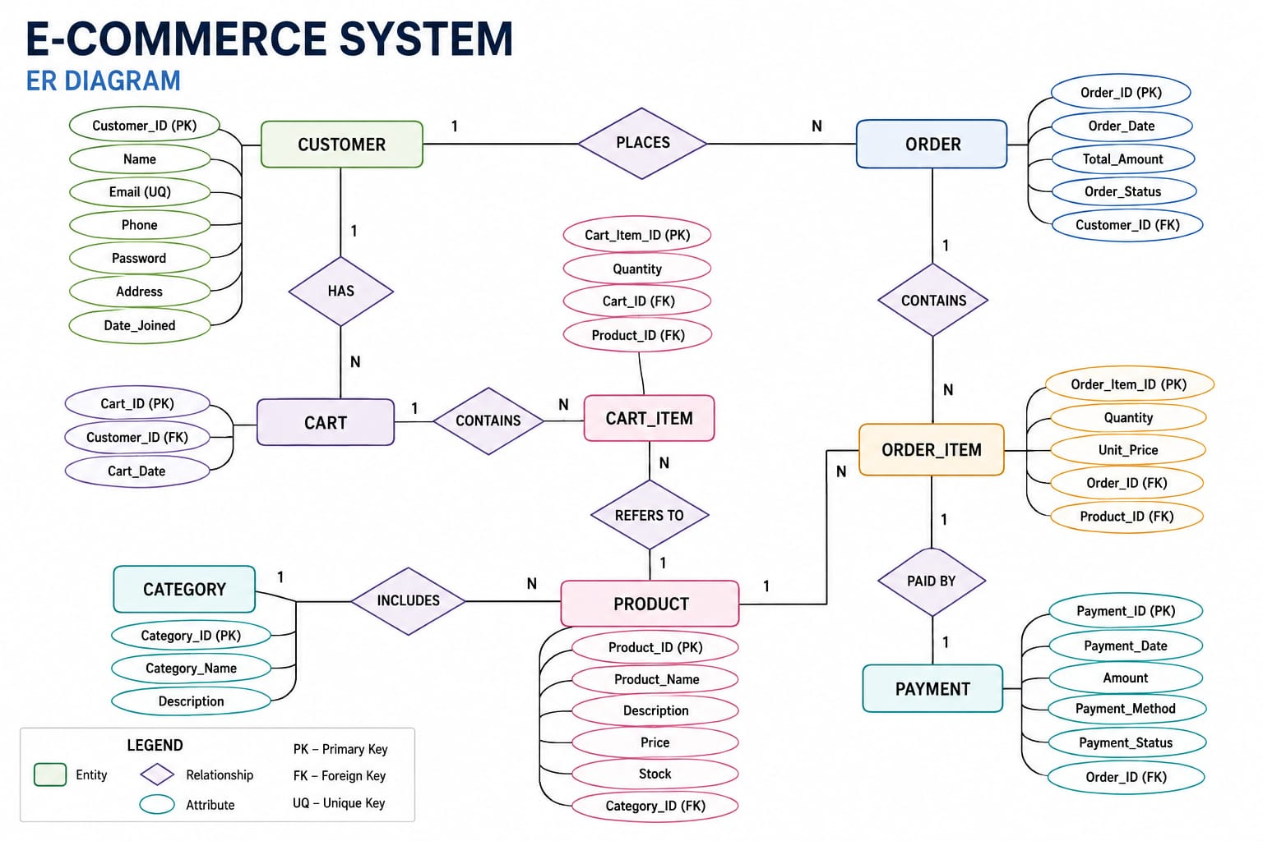

Recommended diagram flow: CUSTOMER 1—M ORDERS; ORDERS 1—M ORDER_ITEM; PRODUCT 1—M ORDER_ITEM; CATEGORY 1—M PRODUCT; ORDERS 1—1/0 PAYMENT; ORDERS 1—1/0 SHIPMENT.

5. RELATIONAL SCHEMA
Relation | Relational Schema
CUSTOMER | Customer_ID (PK), Customer_Name, Email, Phone_No, Address
CATEGORY | Category_ID (PK), Category_Name
PRODUCT | Product_ID (PK), Product_Name, Price, Stock_Qty, Category_ID (FK)
ORDERS | Order_ID (PK), Customer_ID (FK), Order_Date, Order_Status, Total_Amount
ORDER_ITEM | Order_Item_ID (PK), Order_ID (FK), Product_ID (FK), Quantity, Unit_Price
PAYMENT | Payment_ID (PK), Order_ID (FK), Payment_Date, Amount, Payment_Method, Payment_Status
SHIPMENT | Shipment_ID (PK), Order_ID (FK), Shipping_Address, Shipment_Date, Delivery_Status

Team Responsibilities table
Student Name | Roll number | Responsibility | Contribution Status
M.HEMANTH BABU | 25B11AI739 | Presentation outline ,Design, github respo, Project documentation | Completed
G SHARA | 26B21AI038 | Entities & attributes ,ER Diagram, data insertion  Demonstrate & present | Completed
P S D S KRISHNA | 26B21AI097 | Data Schema ,Pk&Fk ,Crud & SQL queries, Data integrity | Completed
CH TEJA SAI DURGA | 25B11AI203 | Database & constraints,  DDL ,DQL ,DML, Conclusion | Completed

Repository Link : https://github.com/hemanthmindrana2008-spec/E-commerce-order-management-system/tree/main

6. TABLE DESIGN

6.1 Customer Table
Attribute | Data Type | Constraint | Description
Customer_ID | NUMBER | PK, NOT NULL | Unique customer identifier
Customer_Name | VARCHAR2 | NOT NULL | Customer name
Email | VARCHAR2 | UNIQUE | Customer email
Phone_No | VARCHAR2 | — | Contact number
Address | VARCHAR2 | — | Customer address

6.2 Category Table
Attribute | Data Type | Constraint | Description
Category_ID | NUMBER | PK, NOT NULL | Unique category identifier
Category_Name | VARCHAR2 | UNIQUE, NOT NULL | Category name

6.3 Product Table
Attribute | Data Type | Constraint | Description
Product_ID | NUMBER | PK | Unique product identifier
Product_Name | VARCHAR2 | NOT NULL | Product name
Price | DECIMAL | CHECK >= 0 | Selling price
Stock_Qty | NUMBER | CHECK >= 0 | Available stock quantity
Category_ID | NUMBER | FK | References Category

6.4 Orders Table
Attribute | Data Type | Constraint | Description
Order_ID | NUMBER | PK | Unique order identifier
Customer_ID | NUMBER | FK, NOT NULL | References Customer
Order_Date | DATE | DEFAULT | Date order was placed
Order_Status | VARCHAR2 | — | Placed, shipped, delivered, cancelled, etc.
Total_Amount | DECIMAL | CHECK >= 0 | Total order value

6.5 Order Item Table
Attribute | Data Type | Constraint | Description
Order_Item_ID | NUMBER | PK | Unique line-item identifier
Order_ID | NUMBER | FK | References Orders
Product_ID | NUMBER | FK | References Product
Quantity | NUMBER | CHECK > 0 | Quantity ordered
Unit_Price | DECIMAL | CHECK >= 0 | Price at time of order

6.6 Payment Table
Attribute | Data Type | Constraint | Description
Payment_ID | NUMBER | PK | Unique payment identifier
Order_ID | NUMBER | FK | References Orders
Payment_Date | DATE | — | Payment date
Amount | DECIMAL | CHECK >= 0 | Payment amount
Payment_Method | VARCHAR2 | — | Card, UPI, COD, etc.
Payment_Status | VARCHAR2 | — | Pending, Paid, Failed, Refunded

6.7 Shipment Table
Attribute | Data Type | Constraint | Description
Shipment_ID | NUMBER | PK | Unique shipment identifier
Order_ID | NUMBER | FK | References Orders
Shipping_Address | VARCHAR2 | — | Delivery address
Shipment_Date | DATE | — | Shipment date
Delivery_Status | VARCHAR2 | — | Processing, Shipped, Delivered, Returned

7. KEYS AND CONSTRAINTS
Constraint Type | Applied To / Purpose
Primary Key | Customer_ID, Category_ID, Product_ID, Order_ID, Order_Item_ID, Payment_ID, Shipment_ID
Foreign Key | Links Product→Category, Orders→Customer, Order_Item→Orders/Product, Payment/Shipment→Orders
NOT NULL | Required names and identifiers
UNIQUE | Customer email and category name where applicable
CHECK | Price and quantity ranges, valid amounts and business rules
DEFAULT | Order date or default status where appropriate

8. NORMALIZATION
Normalization organizes data into related relations to reduce redundancy and update anomalies. The e-commerce order example can be described from UNF to 3NF.

8.1 Unnormalized Form (UNF)
A single order record might contain customer details, repeated product names, quantities, prices, payment information and shipping information. Repeating product groups and duplicated customer/category information create redundancy.

8.2 First Normal Form (1NF)
In 1NF, repeating groups are removed and each attribute contains atomic values. Each product within an order is represented by a separate order-item row.

8.3 Second Normal Form (2NF)
In 2NF, partial dependencies are removed. Customer attributes depend on Customer_ID, product attributes depend on Product_ID, and order-specific attributes depend on Order_ID. This motivates separate Customer, Product, Orders and Order_Item relations.

8.4 Third Normal Form (3NF)
In 3NF, transitive dependencies are removed. Category information is stored in Category, customer information in Customer, product information in Product, payment information in Payment and shipping information in Shipment. The resulting structure supports the 3NF objective.

Relation | Reason for Separation
Customer | Stores customer-specific attributes once.
Category | Stores category-specific attributes once.
Product | Stores product-specific attributes and Category_ID.
Orders | Stores transaction-specific attributes and Customer_ID.
Order_Item | Stores the order-product relationship, quantity and unit price.
Payment | Stores payment-specific information linked to an order.
Shipment | Stores delivery-specific information linked to an order.

9. SQL IMPLEMENTATION

9.1 DDL – Data Definition Language
CREATE TABLE Customer (
Customer_ID NUMBER PRIMARY KEY,
Customer_Name VARCHAR2(100) NOT NULL,
Email VARCHAR2(120) UNIQUE,
Phone_No VARCHAR2(20),
Address VARCHAR2(250)
);
CREATE TABLE Category (
Category_ID NUMBER PRIMARY KEY,
Category_Name VARCHAR2(100) UNIQUE NOT NULL
);
CREATE TABLE Address (
address_id NUMBER PRIMARY KEY,
customer_id NUMBER NOT NULL,
address_line VARCHAR2(200) NOT NULL,
city VARCHAR2(60) NOT NULL,
state VARCHAR2(60),
postal_code VARCHAR2(15) NOT NULL,
country VARCHAR2(60) NOT NULL,
CONSTRAINT fk_address_customer
FOREIGN KEY (customer_id) REFERENCES Customer(customer_id)
);
CREATE TABLE Product (
Product_ID NUMBER PRIMARY KEY,
Product_Name VARCHAR2(150) NOT NULL,
Price NUMBER(10,2) CHECK (Price >= 0),
Stock_Qty NUMBER CHECK (Stock_Qty >= 0),
Category_ID NUMBER,
CONSTRAINT fk_product_category
FOREIGN KEY (Category_ID) REFERENCES Category(Category_ID)
);

CREATE TABLE Orders (
Order_ID NUMBER PRIMARY KEY,
Customer_ID NUMBER NOT NULL,
Order_Date DATE DEFAULT SYSDATE,
Order_Status VARCHAR2(30),
Total_Amount NUMBER(12,2) CHECK (Total_Amount >= 0),
CONSTRAINT fk_order_customer
FOREIGN KEY (Customer_ID) REFERENCES Customer(Customer_ID)
);
CREATE TABLE Order_Item (
Order_Item_ID NUMBER PRIMARY KEY,
Order_ID NUMBER NOT NULL,
Product_ID NUMBER NOT NULL,
Quantity NUMBER CHECK (Quantity > 0),
Unit_Price NUMBER(10,2) CHECK (Unit_Price >= 0),
CONSTRAINT fk_item_order FOREIGN KEY (Order_ID) REFERENCES Orders(Order_ID),
CONSTRAINT fk_item_product FOREIGN KEY (Product_ID) REFERENCES Product(Product_ID)
);
CREATE TABLE Payment (
Payment_ID NUMBER PRIMARY KEY,
Order_ID NUMBER NOT NULL,
Payment_Date DATE,
Amount NUMBER(12,2) CHECK (Amount >= 0),
Payment_Method VARCHAR2(30),
Payment_Status VARCHAR2(30),
CONSTRAINT fk_payment_order FOREIGN KEY (Order_ID) REFERENCES Orders(Order_ID)
);
CREATE TABLE Shipment (
Shipment_ID NUMBER PRIMARY KEY,
Order_ID NUMBER NOT NULL,
Shipping_Address VARCHAR2(250),
Shipment_Date DATE,
Delivery_Status VARCHAR2(30),
CONSTRAINT fk_shipment_order FOREIGN KEY (Order_ID) REFERENCES Orders(Order_ID)
);

9.2 DML – Sample Data

1.Customer

INSERT INTO Customer (Customer_ID,Customer_Name,Email,Phone_No,Address)

VALUES (1,'Rahul Kumar','rahul@gmail.com','9876543210','Kakinada, Andhra Pradesh');

INSERT INTO Customer (Customer_ID,Customer_Name,Email,Phone_No,Address)

VALUES (2,'Priya Sharma','priya@gmail.com','9876543211','Visakhapatnam, Andhra Pradesh');

INSERT INTO Customer (Customer_ID,Customer_Name,Email,Phone_No,Address)

VALUES (3,'Arjun Reddy','arjun@gmail.com','9876543212','Vijayawada, Andhra Pradesh');

INSERT INTO Customer (Customer_ID,Customer_Name,Email,Phone_No,Address)

VALUES (4,'Sneha Rao','sneha@gmail.com','9876543213','Rajahmundry, Andhra Pradesh');

INSERT INTO Customer (Customer_ID,Customer_Name,Email,Phone_No,Address)

VALUES (5,'Kiran Kumar','kiran@gmail.com','9876543214','Hyderabad, Telangana');

2.Category

INSERT INTO Category (Category_ID,Category_Name)

VALUES (1,'Electronics');

INSERT INTO Category (Category_ID,Category_Name)

VALUES (2,'Clothing');

INSERT INTO Category (Category_ID,Category_Name)

VALUES (3,'Books');

INSERT INTO Category (Category_ID,Category_Name)

VALUES (4,'Home Appliances');

INSERT INTO Category (Category_ID,Category_Name)

VALUES (5,'Sports');

3.Address

INSERT INTO Address (address_id,customer_id,address_line,city,state,postal_code,country)

VALUES (101,1,'12 Main Road','Kakinada','Andhra Pradesh','533001','India');

INSERT INTO Address (address_id,customer_id,address_line,city,state,postal_code,country)

VALUES (102,2,'25 Beach Road','Visakhapatnam','Andhra Pradesh','530001','India');

INSERT INTO Address (address_id,customer_id,address_line,city,state,postal_code,country)

VALUES (103,3,'45 MG Road','Vijayawada','Andhra Pradesh','520001','India');

INSERT INTO Address (address_id,customer_id,address_line,city,state,postal_code,country)

VALUES (104,4,'10 Station Road','Rajahmundry','Andhra Pradesh','533101','India');

INSERT INTO Address (address_id,customer_id,address_line,city,state,postal_code,country)

VALUES (105,5,'18 Banjara Road','Hyderabad','Telangana','500034','India');

4.Product

INSERT INTO Product (Product_ID,Product_Name,Price,Stock_Qty,Category_ID)

VALUES (201,'Wireless Headphones',2499,50,1);

INSERT INTO Product (Product_ID,Product_Name,Price,Stock_Qty,Category_ID)

VALUES (202,'Smart Watch',3999,30,1);

INSERT INTO Product (Product_ID,Product_Name,Price,Stock_Qty,Category_ID)

VALUES (203,'Cotton T-Shirt',799,100,2);

INSERT INTO Product (Product_ID,Product_Name,Price,Stock_Qty,Category_ID)

VALUES (204,'Java Programming Book',650,25,3);

INSERT INTO Product (Product_ID,Product_Name,Price,Stock_Qty,Category_ID)

VALUES (205,'Electric Kettle',1499,8,4);

INSERT INTO Product (Product_ID,Product_Name,Price,Stock_Qty,Category_ID)

VALUES (206,'Cricket Bat',2499,15,5);

5.Orders

INSERT INTO Orders (Order_ID,Customer_ID,Order_Date,Order_Status,Total_Amount)

VALUES (301,1,TO_DATE('2026-09-01','YYYY-MM-DD'),'PLACED',2499);

INSERT INTO Orders (Order_ID,Customer_ID,Order_Date,Order_Status,Total_Amount)

VALUES (302,2,TO_DATE('2026-09-02','YYYY-MM-DD'),'PAID',3999);

INSERT INTO Orders (Order_ID,Customer_ID,Order_Date,Order_Status,Total_Amount)

VALUES (303,3,TO_DATE('2026-09-03','YYYY-MM-DD'),'SHIPPED',1449);

INSERT INTO Orders (Order_ID,Customer_ID,Order_Date,Order_Status,Total_Amount)

VALUES (304,4,TO_DATE('2026-09-04','YYYY-MM-DD'),'DELIVERED',1499);

INSERT INTO Orders (Order_ID,Customer_ID,Order_Date,Order_Status,Total_Amount)

VALUES (305,5,TO_DATE('2026-09-05','YYYY-MM-DD'),'CANCELLED',2499);

6.Order_Item

INSERT INTO Order_Item (Order_Item_ID,Order_ID,Product_ID,Quantity,Unit_Price)

VALUES (401,301,201,1,2499);

INSERT INTO Order_Item (Order_Item_ID,Order_ID,Product_ID,Quantity,Unit_Price)

VALUES (402,302,202,1,3999);

INSERT INTO Order_Item (Order_Item_ID,Order_ID,Product_ID,Quantity,Unit_Price)

VALUES (403,303,203,1,799);

INSERT INTO Order_Item (Order_Item_ID,Order_ID,Product_ID,Quantity,Unit_Price)

VALUES (404,303,204,1,650);

INSERT INTO Order_Item (Order_Item_ID,Order_ID,Product_ID,Quantity,Unit_Price)

VALUES (405,304,205,1,1499);

INSERT INTO Order_Item (Order_Item_ID,Order_ID,Product_ID,Quantity,Unit_Price)

VALUES (406,305,206,1,2499);

7.Payment

INSERT INTO Payment (Payment_ID,Order_ID,Payment_Date,Amount,Payment_Method,Payment_Status)

VALUES (501,301,TO_DATE('2026-09-01','YYYY-MM-DD'),2499,'UPI','PENDING');

INSERT INTO Payment (Payment_ID,Order_ID,Payment_Date,Amount,Payment_Method,Payment_Status)

VALUES (502,302,TO_DATE('2026-09-02','YYYY-MM-DD'),3999,'CARD','PAID');

INSERT INTO Payment (Payment_ID,Order_ID,Payment_Date,Amount,Payment_Method,Payment_Status)

VALUES (503,303,TO_DATE('2026-09-03','YYYY-MM-DD'),1449,'UPI','PAID');

INSERT INTO Payment (Payment_ID,Order_ID,Payment_Date,Amount,Payment_Method,Payment_Status)

VALUES (504,304,TO_DATE('2026-09-04','YYYY-MM-DD'),1499,'CASH','PAID');

INSERT INTO Payment (Payment_ID,Order_ID,Payment_Date,Amount,Payment_Method,Payment_Status)

VALUES (505,305,TO_DATE('2026-09-05','YYYY-MM-DD'),2499,'CARD','REFUNDED');

8. Shipment

INSERT INTO Shipment (Shipment_ID,Order_ID,Shipping_Address,Shipment_Date,Delivery_Status)

VALUES (601,301,'12 Main Road, Kakinada, Andhra Pradesh','2026-09-02','Processing');

INSERT INTO Shipment (Shipment_ID,Order_ID,Shipping_Address,Shipment_Date,Delivery_Status)

VALUES (602,302,'25 Beach Road, Visakhapatnam, Andhra Pradesh','2026-09-03','Shipped');

INSERT INTO Shipment (Shipment_ID,Order_ID,Shipping_Address,Shipment_Date,Delivery_Status)

VALUES (603,303,'45 MG Road, Vijayawada, Andhra Pradesh','2026-09-04','Shipped');

INSERT INTO Shipment (Shipment_ID,Order_ID,Shipping_Address,Shipment_Date,Delivery_Status)

VALUES (604,304,'10 Station Road, Rajahmundry, Andhra Pradesh','2026-09-05','Delivered');

INSERT INTO Shipment (Shipment_ID,Order_ID,Shipping_Address,Shipment_Date,Delivery_Status)

VALUES (605,305,'18 Banjara Road, Hyderabad, Telangana','2026-09-06','Cancelled');

10. SQL QUERIES & REPORTS

Q1. Display all customers

SELECT * FROM Customer;
Output:
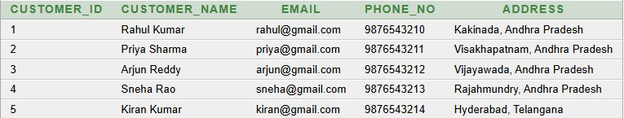

Q2: Display all addresses
SELECT * FROM Address;
Output:
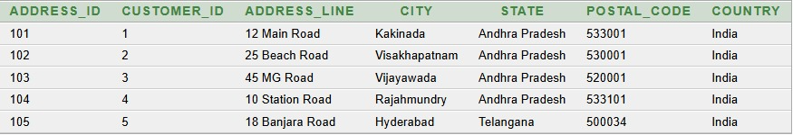

Q3. Customers with email
SELECT Customer_ID, Customer_Name, Email FROM Customer WHERE Email IS NOT NULL;
Output:
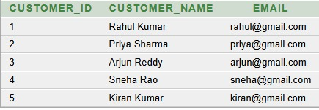
Q4. Display addresses for a specific customer

SELECT * FROM Address WHERE Customer_ID=1;
Output:
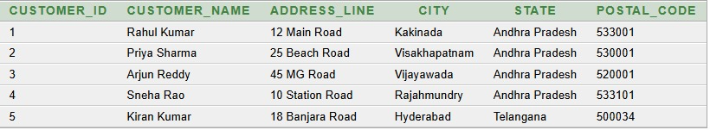

Q5. Customers with their addresses
SELECT c.Customer_ID, c.Customer_Name, a.Address_Line, a.City, a.State, a.Postal_Code FROM Customer c JOIN Address a ON c.Customer_ID=a.Customer_ID;
Output:

Q6. Display addresses by city
SELECT * FROM Address WHERE City='Kakinada';
Output:
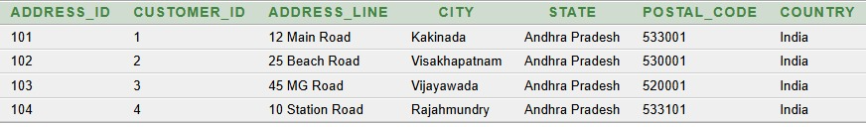

Q7. Display addresses by state
SELECT * FROM Address WHERE State='Andhra Pradesh’;
Output :
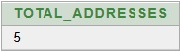
Q8. Count total addresses
SELECT COUNT(*) AS Total_Addresses FROM Address
;
Output:

Q9. Number of addresses per customer
SELECT Customer_ID, COUNT(*) AS Address_Count FROM Address GROUP BY Customer_ID;
Output:
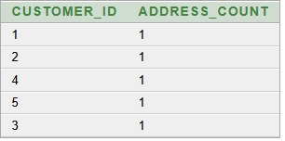

Product & Category

Q10. Display all product

SELECT * FROM Product;

Output:

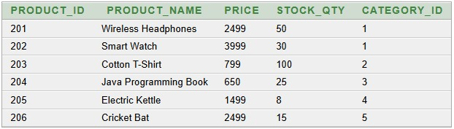

Q11. Products above a price

SELECT * FROM Product WHERE Price > 1000;

Output:

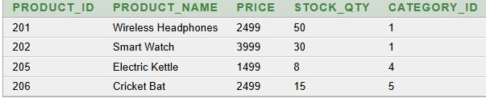

Q12. Products sorted by price

SELECT * FROM Product ORDER BY Price DESC;

Output:

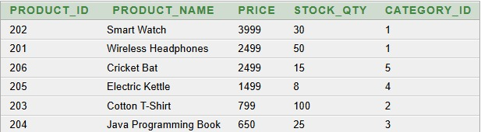

Q13. Products by category

SELECT p.Product_Name, c.Category_Name FROM Product p JOIN Category c ON p.Category_ID=c.Category_ID;

Output:

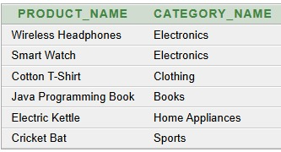

Q14. Number of products by category

SELECT Category_ID, COUNT(*) FROM Product GROUP BY Category_ID;

Output:

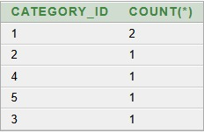

Q15. Products with low stock

SELECT * FROM Product WHERE Stock_Qty < 10;

Output:

Q16. Search product by keyword

SELECT * FROM Product WHERE UPPER(Product_Name) LIKE '%PHONE%';

Output:

Q17. Average product price

SELECT AVG(Price) AS Average_Price FROM Product;

Output:

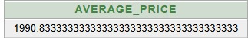

Q18. Maximum product price

SELECT MAX(Price) AS Max_Price FROM Product;

Output:

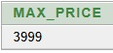

Q19. Minimum product price

SELECT MIN(Price) AS Min_Price FROM Produ

ct;

Output:

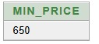

Orders & Order Items

Q20. Orders by status

SELECT * FROM Orders WHERE Order_Status='PLACED';

Output:

Q21. Orders with customer names

SELECT o.Order_ID, c.Customer_Name, o.Total_Amount FROM Orders o JOIN Customer c ON o.Customer_ID=c.Customer_ID;

Output:

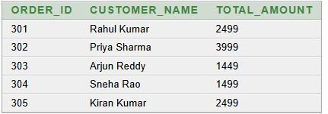

Q22. Order items with products

SELECT oi.Order_ID, p.Product_Name, oi.Quantity FROM Order_Item oi JOIN Product p ON oi.Product_ID=p.Product_ID;

Output:

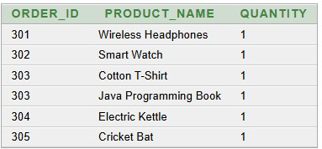

Q23. Count total orders

SELECT COUNT(*) AS Total_Orders FROM Orders;

output:

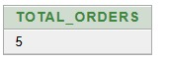

Q24. Orders per customer

SELECT Customer_ID, COUNT(*) AS Order_Count FROM Orders GROUP BY Customer_ID;

Output:

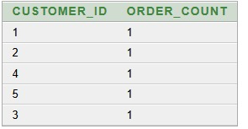

Q25. Units sold per product

SELECT Product_ID, SUM(Quantity) AS Units_Sold FROM Order_Item GROUP BY Product_ID;

Output:

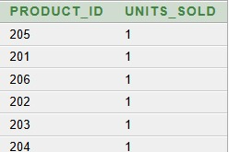

Q26. Order status summary

SELECT Order_Status, COUNT(*) FROM Orders GROUP BY Order_Status;

Output:

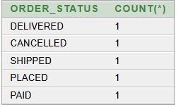

Q27. Customer order history

SELECT c.Customer_Name, o.Order_ID, o.Order_Date, o.Order_Status FROM Customer c JOIN Orders o ON c.Customer_ID=o.Customer_ID;

Output:

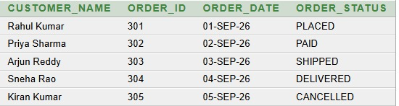

Q28. Orders above amount

SELECT * FROM Orders WHERE Total_Amount > 2499;

Output:

Q29. Average order value

SELECT AVG(Total_Amount) AS Average_Order_Value FROM Orders;

Output:

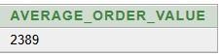

Q30. Highest-value order

SELECT * FROM Orders WHERE Total_Amount=(SELECT MAX(Total_Amount) FROM Orders);

Output:

Q31. Customers with orders

SELECT DISTINCT c.Customer_Name FROM Customer c JOIN Orders o ON

c.Customer_ID=o.Customer_ID;

Output:

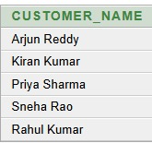

Payment & Shipment

Q32. Payment details

SELECT o.Order_ID, p.Amount, p.Payment_Method, p.Payment_Status FROM Orders o JOIN Payment p ON o.Order_ID=p.Order_ID;

Output:

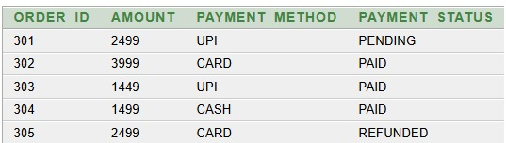

Q33. Pending payments

SELECT * FROM Payment WHERE Payment_Status='Paid';

Output:

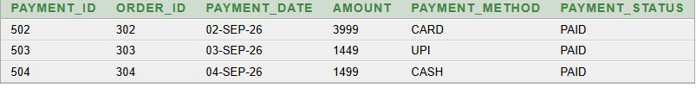

Q34. Total delivered sales

SELECT SUM(Total_Amount) AS Total_Sales FROM Orders WHERE

Order_Status='DELIVERED';

Output:

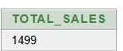

Q35. Shipment details

SELECT o.Order_ID, s.Shipping_Address, s.Delivery_Status FROM Orders o JOIN Shipment s ON o.Order_ID=s.Order_ID;

Output:

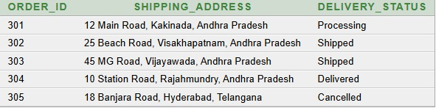

Q36. Delivered shipments

SELECT * FROM Shipment WHERE Delivery_Status='Delivered';

Output:

11. CONCLUSION
The E-Commerce Order Management System provides a structured relational database solution for managing customers, categories, products, orders, order items, payments and shipments. The design organizes business information into related relations and applies primary keys, foreign keys, uniqueness rules, NOT NULL conditions and CHECK constraints to support data integrity. The normalization process up to 3NF reduces redundancy and update anomalies. The SQL implementation and query set demonstrate insertion, retrieval, joins, aggregation and operational reporting.

12. FUTURE ENHANCEMENTS
- Role-based access for administrators, customers and ope
- rational staff.
- Inventory reservation and automatic stock updates.
- Coupon, discount, tax and promotion management.
- Returns, cancellations and refund processing.
- Automated email/SMS/order notifications.
- Analytics dashboards for sales and customer behavior.
- Audit logging, backup, recovery and stronger database security.
- Integration with web and mobile e-commerce applications.

13. REFERENCES
- Silberschatz, H. F. Korth and S. Sudarshan, Database System Concepts, McGraw Hill.
- Elmasri, R. and Navathe, S. B., Fundamentals of Database Systems, Pearson.
- Supplied DBMS Cornerstone Project documentation used as the structural reference for this documentation.

